Fact Sheet: NORAD Interceptor Flares
The North American Aerospace Defense Command (NORAD) is tasked with air sovereignty and air defense of the United States and Canada against attack from all enemies -- foreign and domestic. Since Sept. 11, 2001, NORAD operations have continued in close coordination with the Transportation Security Administration and the Federal Aviation Administration. These operations include incorporating Temporary Flight Restrictions or TFRs.
In a continuing effort to safely enforce TFRs, NORAD interceptors have developed procedures to communicate with aircraft that have unknown intentions.
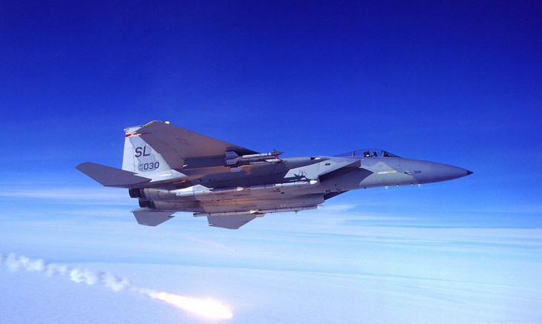
These procedures augment standard International Civil Aviation Organization interceptor procedures and will soon be included in the Aeronautical Information Manual (AIM).

A NORAD interceptor dispensing flares in your vicinity is attempting to communicate the following:
1. Pay attention
2. Contact Air Traffic Control immediately on the local frequency or 121.5 / 243.0
3. Follow the interceptor's visual ICAO signals
4. Non-compliance may result in the use of force
These procedures will be done with the highest regard for the safety of the intercepted aircraft and its passengers, and are practiced regularly by NORAD assets. As always, aircraft not complying with posted flight restrictions face certificate action and possible prosecution.
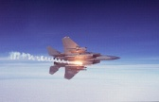
Every person operating aircraft in the United States and Canada has an important role to play in air sovereignty through thorough flight planning, and review of posted flight restrictions and Notice to Airmen information. Wide dissemination and understanding of what it means when flares are dispensed is an important part of this flight planning process.
For questions about NORAD call Headquarters NORAD Public Affairs at (719) 554-6889. The NORAD website is www.norad.mil

